# Dashboard Presentation Report

**Introduction**

The dashboard titled ‘Zimbabwe-South Africa Migration Study 2019-2022 looks at the migration patterns and trends over a 4-year period between the two countries. This dashboard has been designed to be used by an Inter-Ministerial Task Committee responsible for investigating migration patterns and the impact this has on the brain drain in Zimbabwe.

The data for this dashboard was collected through surveys conducted at ports of entry into Zimbabwe by field agents. A tool was designed in close consultation with the audience and stakeholders to ensure that relevant indicators were included that would answer key questions and give key insights.

**Overview**

The dashboard was designed in Tableau and the data was derived from Microsoft Excel, stored in a shared SharePoint file.

The dashboard consists of 10 charts, which include a trend chart, histogram, bar charts and a pie chart. For further data exploration, the dashboard has two date filters, one by year and another by month. Further to this under the survey questions section of the dashboard, the Movements by Sex chart can be used as a filter for more detailed information. The top section of the dashboard gives an overview of the type of movements observed and the numbers recorded. Finally, a legend was included depicting the colours used to differentiate the gender types.

The dashboard uses 2 data sources, the first is data from the surveys and the second source of data is from the Immigration Department which recorded the daily total movements observed. Surveys were conducted on weekdays, between 8 a.m. to 5 p.m., except on major holidays. Data from the surveys was collected using KOBO Collect and downloaded from the KOBO servers in Excel format.

**Objectives**

Studying migration patterns and trends can be an exhaustive task as large volumes of data are collected daily as people travel between countries. The purpose of this dashboard is to identify relevant data and synthesize the volume of data into meaningful and actionable insights (Few, S,2013). It will allow for the key stakeholders and audience to make informed decisions and provide near-real-time monitoring of migration events as they unfold. The interactivity of the dashboard will empower the audience to explore and interact with the data and gain a deeper understanding. Allowing the audience to ask relevant follow-up questions that build onto the analysis (Murray, S,2013).

**Design Principles**

**The Inter-Ministerial Committee is comprised of 10 individuals who meet monthly to discuss migration and immigration-related issues. Considering the number of members within the committee, the dashboard has to be easily accessible and easy to follow and read. Thus, to ensure that there was less of a learning curve for the audience, simple and common charts were used to build the dashboard. The choice of graphs and layout were deliberately made to ensure that the audience could interpret it at first glance. In terms of design, the choice of colours was to aid in the explanatory analysis. According to Knaflic (2022), you should know what your audience wants to know and how you want your audience to act. In this case, the audience is interested in seeing disaggregated data. The reason is that the intersectionality between gender and age has a bearing on migration, i.e., reasons for migration vary by gender and age. Thus, colour was used to distinguish the different genders in some of the charts.**

***Fig 1 Dashboard Design: Source Tableau***

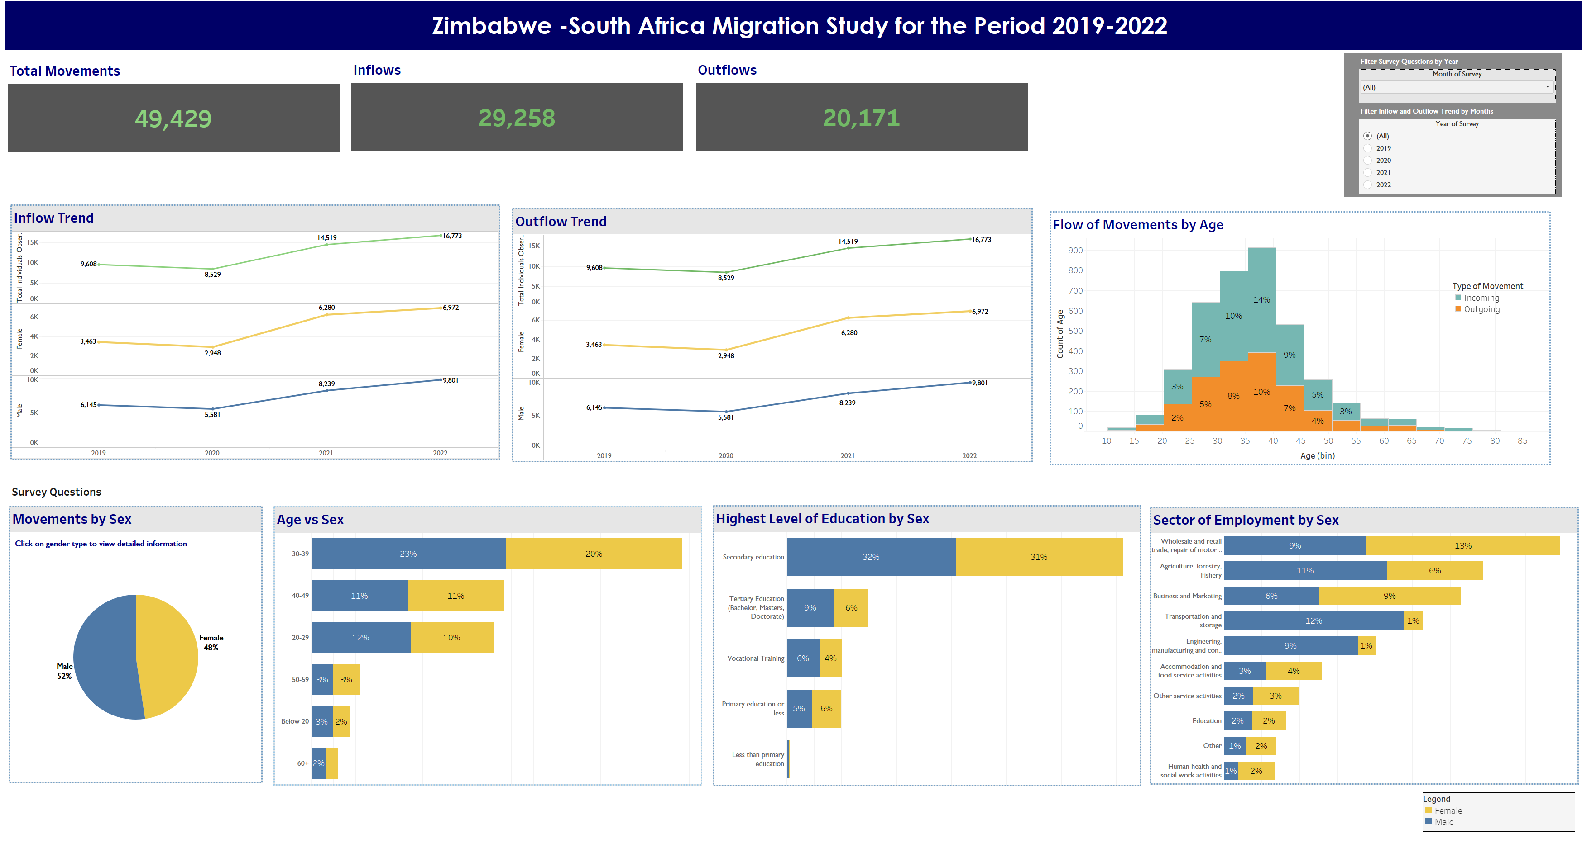

**The image above shows the complete dashboard. Only 1 dashboard was designed to convey all the relevant data points.**

**For easy reading and navigation, the dashboard layout has been divided into 3 parts, the header section, the trends section, and the survey questions section.**

**The header section contains the dashboard title in a large bold heading placed at the top, “Zimbabwe-South Africa Migration Study for the Period 2019-2022”. The second part of the header section contains information on the Total Movements, Inflows and Outflows presented as simple text in contrasting colours for high visibility, and to draw attention to important figures.**

**The trend section of the dashboard consists of 3 charts, The Inflow Trend, The Outflow Trend and the Flow Movements by Age chart.**

**The Inflow Trend chart shows the number of people who travelled to Zimbabwe over 4 years from South Africa. The chart depicts the Total inflow movements recorded, the Total movements by female migrants, and the Total movements by male migrants. Each of the indicators is presented in different colours, Total movements are presented in Green, and Male and Female migrants are presented in Blue and Yellow respectively. Throughout the dashboard, the Male and Female migrants are presented in Blue and Yellow respectively, for easy reading and consistency in the analysis.**

**The second chart in this section is the Outflow trend chart which shows the total number of people who left Zimbabwe during the reporting period. The indicators are presented in the same colours as the Inflow trend chart. This is to allow the audience to compare the trends easily. For the trend charts, line charts were chosen to convey multiple series of data over a period.**

**The third chart in the trends section is a histogram showing the distribution of ages of migrants segmented by the type of movement, inflow, or outflow.**

**The last section is the survey question section. This section consists of 4 charts all showing disaggregated data by gender. Stacked horizontal bar charts were used to show categorical data, that is age, sector of employment and level of education, between genders.**

**Lastly, the dashboard contains a filter in the top left corner. Two filters have been included to be used for exploratory analysis. However, the filters do not apply to all the charts. The month filter drills down the Trend charts to compare month-on-month movements for each year. While the Year filter shows the varying responses to survey questions by year and the distribution of movements by age.**

**A legend has been included in the bottom left corner showing the colours depicting male and female migrants.**

**References**

1. **Few, S. (2013) Information Dashboard Design. Analytics Press. 2nd edition.**
2. **Murray, S. (2013) Interactive Data Visualization. O’Reilly Media.**
3. **Knaflic, C. (2022). Storytelling with data: a data visualization guide for business professionals. Wiley.**